

Puckane & District Tennis club are delighted to confirm that we have upgraded the lighting control system on the club grounds so that the existing lights for both courts can now be switched on by using a mobile phone.

Scroll down to see detailed worksteps on how to use the online system, or click on the shortcuts shown here:

- IMPORTANT! - Delete previous lighting control app!
- Accessing new Webapp for lighting control
- Logging In
- Adding Credits
- Switching on Lights
- Forgotten Password
- Don’t know if you have an existing profile?
- Registering a new profile
- Log in Errors

1. IMPORTANT! Delete previous lighting control app

If you were a member in 2022 or earlier, you may still have an old app on your phone for the previous online lighting system. Please delete it!


DELETE THIS OLD LIGHTING APP, IT WILL NOT WORK!

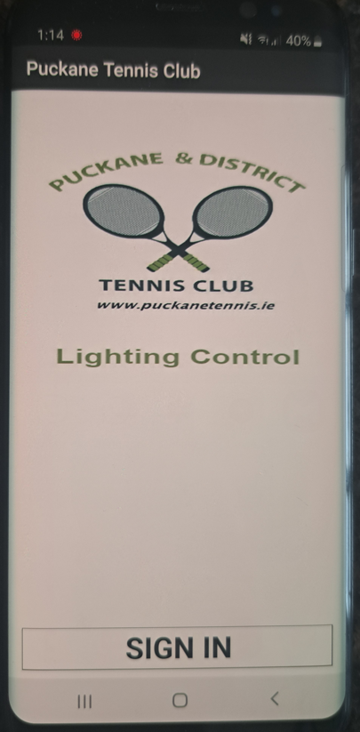

THIS IS THE OLD APP, DO NOT TRY TO USE IT, IT SHOULD BE DELETED

2. How to access new Webapp for online lighting control

The new lighting controls system is a Webapp that relies on a broadband connection in the clubhouse and a reliable mobile network on your phone.

We have found that the mobile network connection works best :
- ON COURT
- BETWEEN THE TWO COURTS
- IN THE CARPARK
We advise to avoid trying to control the lights on your phone while inside the clubhouse or on the benches right outside the clubhouse as the mobile network connection is not as reliable.
Click on the Link or Scan QR Code
To use the online lighting control for the first time you can access the link by either scanning the QR Code or clicking on the following link:
https://lightingsports.com/puckanetennisclub/app.aspx

To scan the QR code, open the camera on your phone, hold your phone over the QR Code shown here:

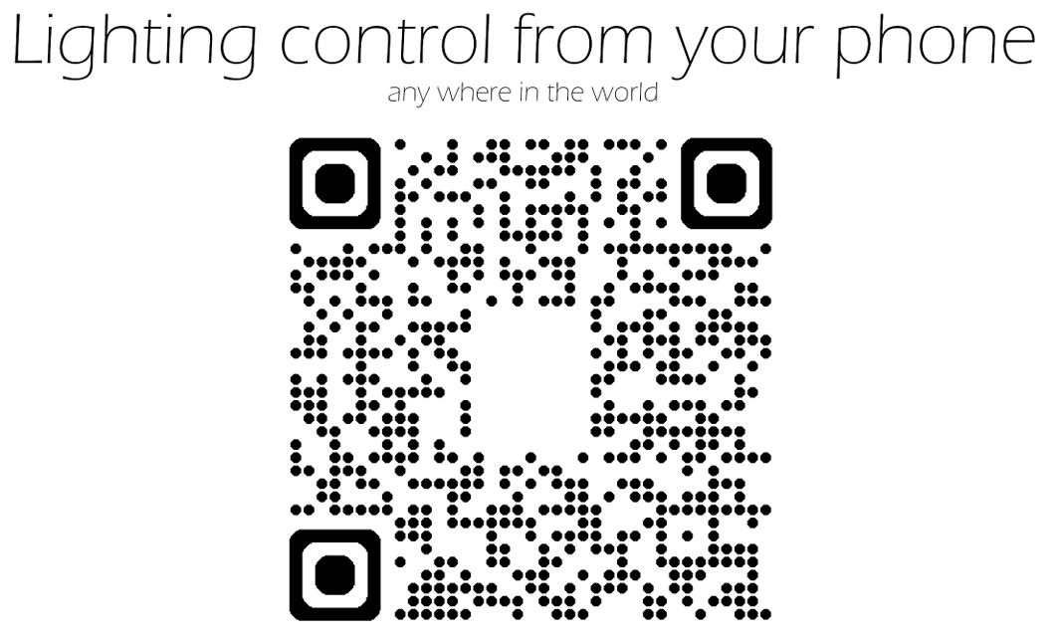

Your phone will scan the QR Code, a text box or prompt of some kind will appear somewhere on the screen, below are two such examples with the prompt outlined in red.
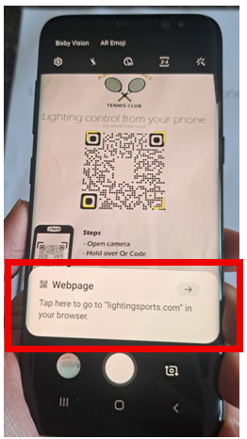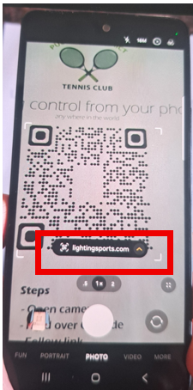

Click on the prompt and this will bring you to the login screen of the Webapp.

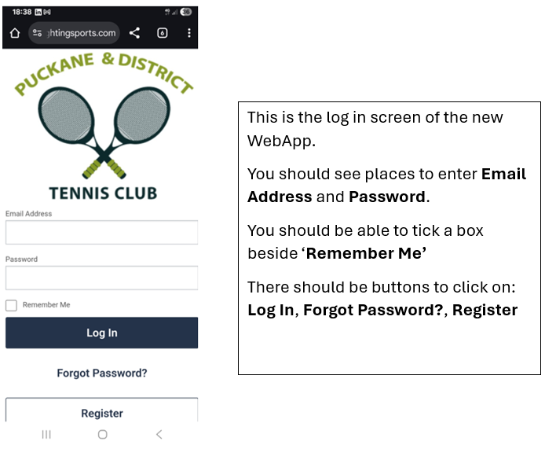

At this point, for easy access in future, you can either:
- add the link as a bookmark/favourites
or
- add to your home screen.
How to do this will vary depending on what kind of phone you have.
For this particular Samsung phone, I click on the 3 dots on the top right hand corner of the screen and this opens a menu as shown below
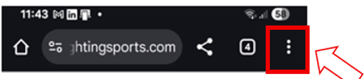
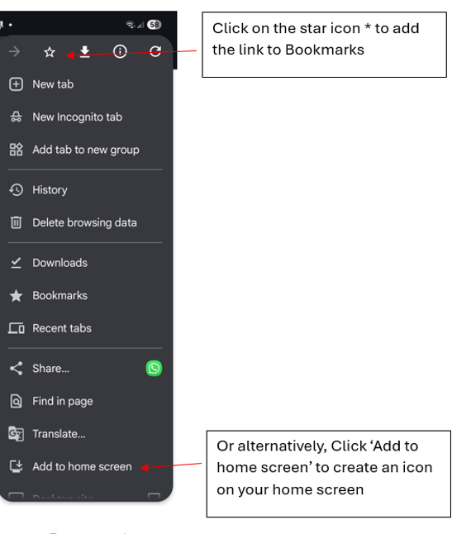

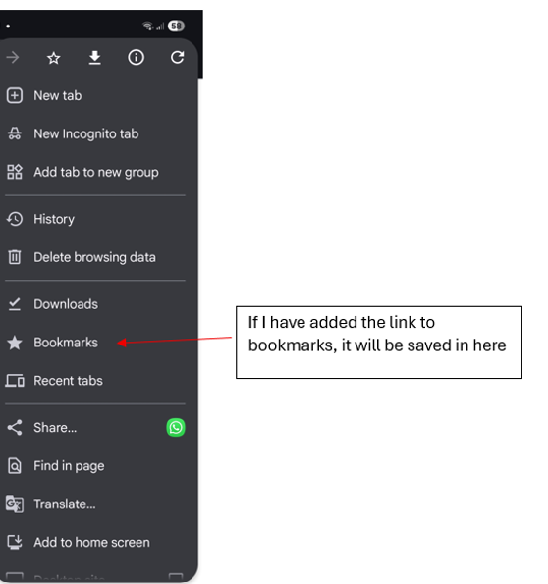

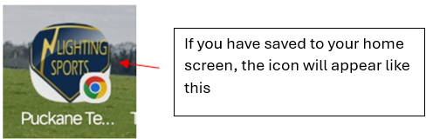

3. Logging In
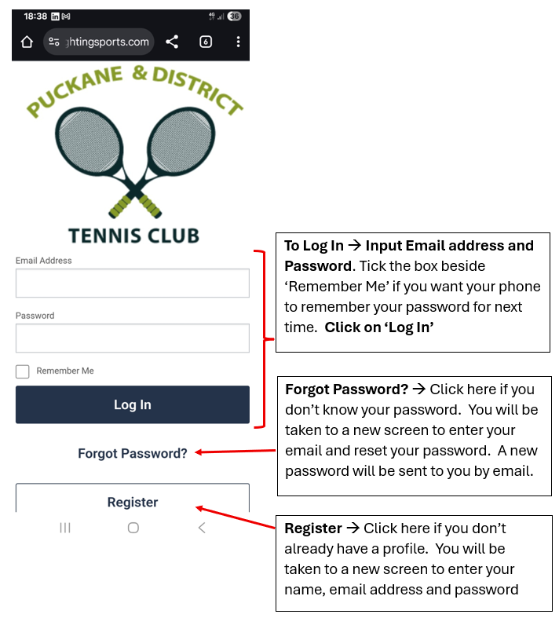

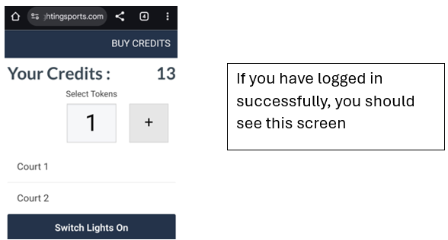

4. Adding credits
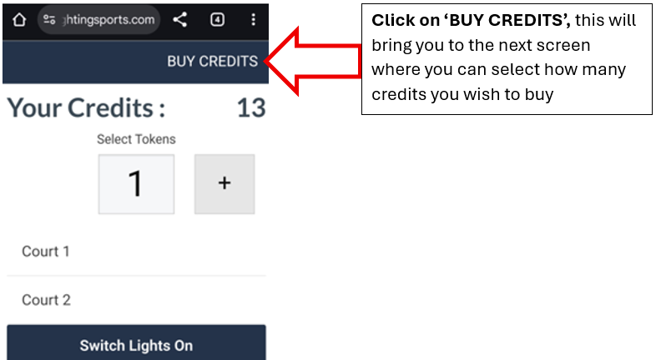

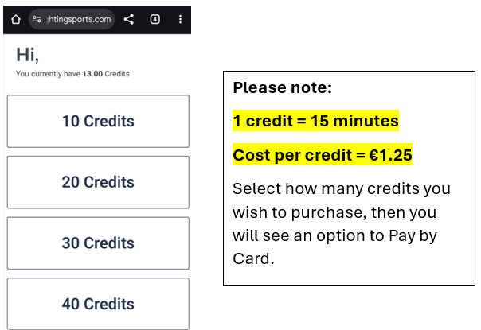
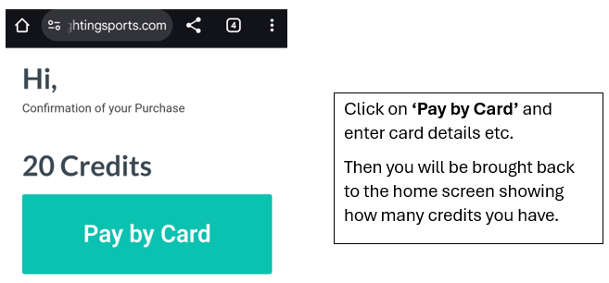

5. Switching on the lights
Always keep in mind that the connection to the online lighting system is fully dependant on the broadband connection in the clubhouse, and the mobile network connection on your phone. Mobile network connection is very limited in or near the clubhouse.
We have found that the mobile network connection works best :
- ON COURT
- BETWEEN THE TWO COURTS
- IN THE CARPARK
Follow the steps below to use your credits to switch on the lights, preferably while standing in one of the areas highlighted above.
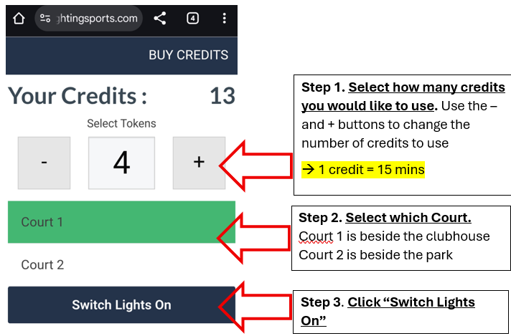

Allow a few seconds for the lights to come on.

6. Forgotten password
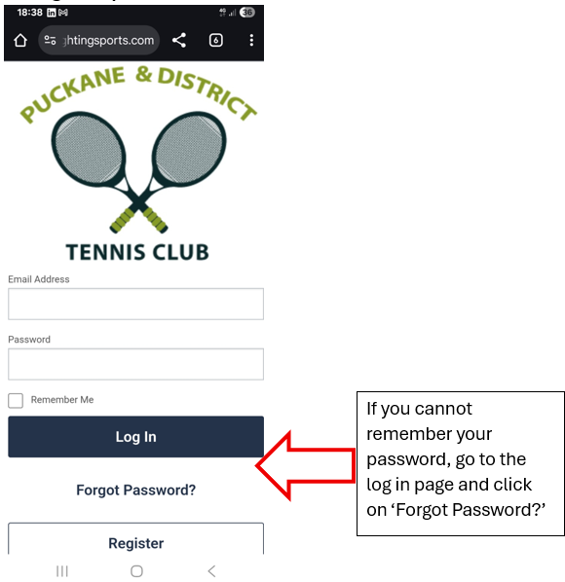

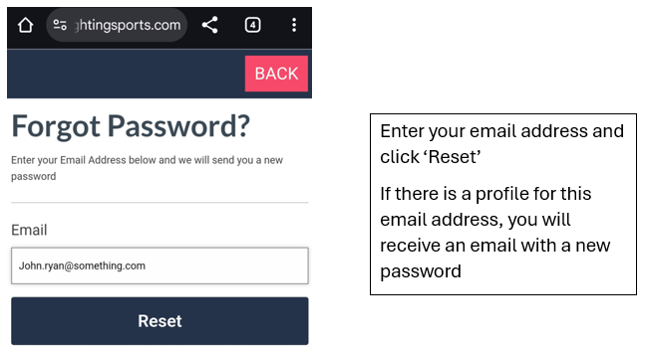

7. Don’t know if you have an existing profile?
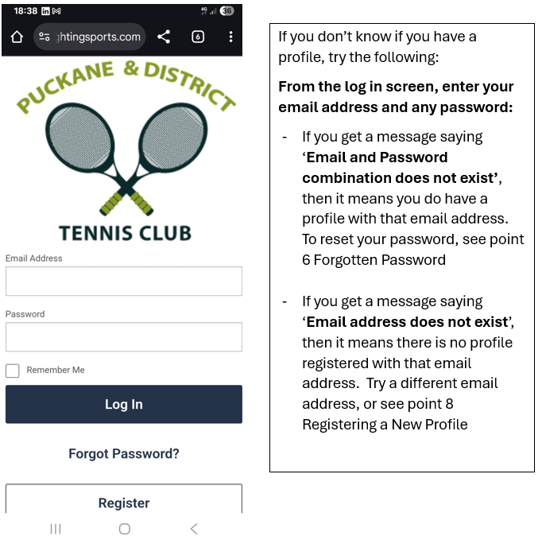

8. Registering a new profile
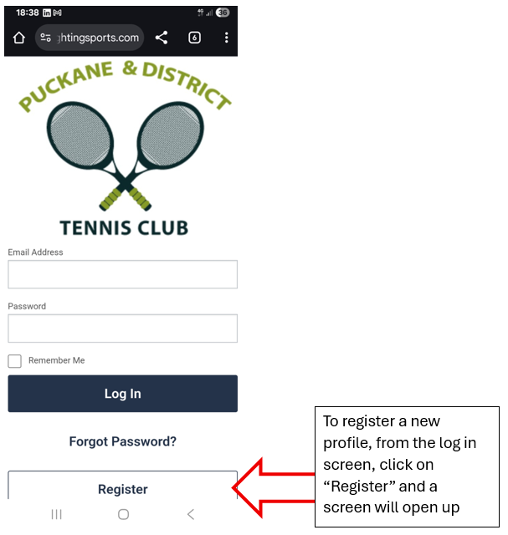

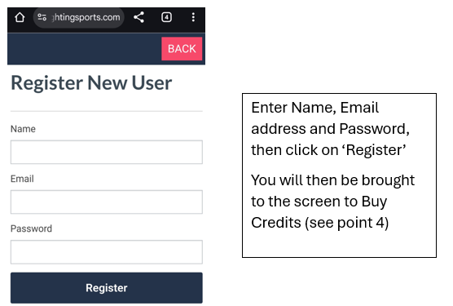

9. Log in Errors

-> Error Message: Email and Password combination doesn’t match
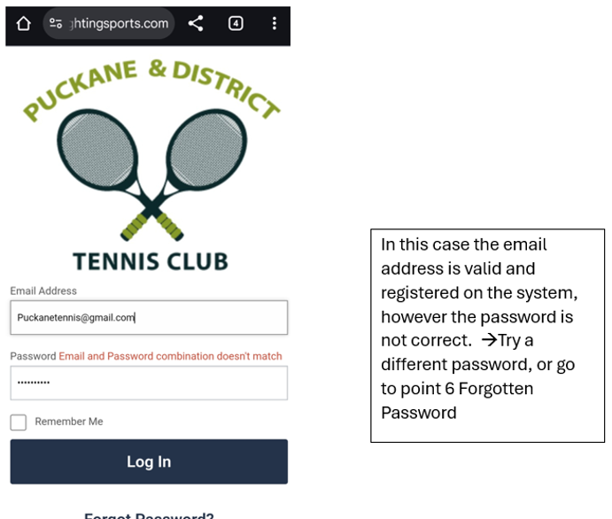

-> Error Message: Email address does not exist
